Alright, hypertuning an RNN. One of my favorite things to do with models is to experiment with the parameters, so this is the perfect week to test my skills on something we learned about!
I wanted to use a similar approach to the first week, where we also had to change parameters to see what worked, like the dropout. Right now, we need to create a better model that achieves over 0.900 accuracy. According to the instructions, this should be easily done, and yes, that turned out to be totally true. With the given RNN script, we could reach 0.900 in around 10 epochs.
So, I created a grid where my searches would go, to avoid random numbers and random results. I first experimented with the parameters manually. Here are some things I found:
- Using a high learning rate (like 0.1) doesn’t work at all; it performs very poorly.
- Early stopping helped a lot in saving time, some runs even ended in around 20 epochs, which saved 2–3 minutes per run.
- A hidden layer size of 32 gave similar performance compared to 64 and 128. Slightly worse than the others, but still good enough considering it uses much fewer parameters.
After my random search, I decided to approach hypertuning in a different way: namely, via an automated script that tries out a number of different models, given the parameters below.
hidden_sizes = [32, 64, 128]
num_layers_options = [1, 2, 3]
dropouts = [0.0, 0.1, 0.2, 0.3]
learning_rates = [0.001, 0.0005, 0.0001]

I ran through 30 different models, with a total training time of around 2 hours (115 minutes to be precise). Using this automatic script, the model chooses random parameters and avoids duplicates. With this approach, we easily surpassed the 0.900 accuracy that was given as the minimum bar.
What I found is that hidden unit size 128 was the sweet spot for these models. The top 5 performing models all used 128 units. It might be worth exploring even higher sizes, like 256 or 512, although given these already high accuracies, it may be overkill.
The number of layers was mostly 3, with the exception of the best-performing model using only 2. Interestingly, models with 3 layers often required longer training times than those with 2 layers. So, while deeper models sometimes performed well, longer training didn’t always guarantee the best performance.
Dropout was a bit inconsistent, and I couldn’t find a clear pattern to draw strong conclusions from it.
For the learning rate, most models used 0.001 or 0.0001, but never 0.0005, which is quite odd. When 0.0005 was used, models consistently performed worse.
Name | Accuracy max | Hidden layer size | Number of Layers | Dropout | Learning rate
Intrigued fly 96 | 0.976 | 128 | 2 | 0.2 | 0.001
Painted Moth 165 | 0.971 | 128 | 3 | 0.3 | 0.0001
Blushing newt 123 | 0.9640625 | 128 | 3 | 0.1 | 0.0001
Victorious Hound 539 | 0.9640625 | 128 | 3 | 0.0 | 0.001
Unleashed Gnu 130 | 0.9640625 | 128 | 3 | 0.1 | 0.0001

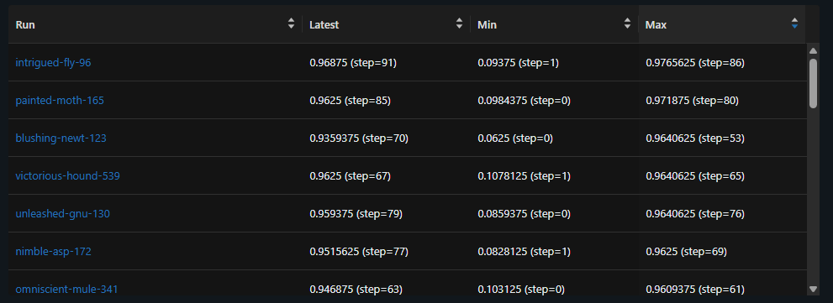

Okidoki, using the Conv1D layers made all models perform extremely better. We see an increase of about 0.02–0.03, pushing the accuracies up to around 99%. With that in mind, we also notice that the convergence rate is much faster. Without Conv1D, it took roughly 75 epochs to reach the maximum accuracy, whereas now it’s done in around 15 steps. That’s amazing!
The ranking of the models shifts slightly: Painted Moth surpasses Intrigued Fly, with a small difference of 0.003, while Intrigued Fly reaches high accuracy in fewer steps. Even though Conv1D makes the models perform almost perfectly, we still need to remember that the hyperparameters remain crucial, as they set a baseline for future models.
Name | Accuracy max (without Conv1D) | Accuracy max (with Conv1D)
Intrigued fly 96 | 0.97665625 (step=86) (1) | 0.9921875 (step=12) (2)
Painted Moth 165 | 0.971875 (step=80) (2) | 0.9953125 (step=15) (1)
Blushing newt 123 | 0.9640625 (step=53) (3) | 0.990625 (step=16) (3)
Victorious Hound 539 | 0.9640625 (step=76) (4) | 0.9890625 (step=13) (4)
Unleashed Gnu 130 | 0.9640625 (step=69) (5) | 0.9859375 (step=6) (5)

